Syeda Reeha Quasar

14114802719

4C7

Aim

Write a program to enter any number and find its factorial using constructor.

Experiment - 13

Object Oriented Programming Lab

# **EXPERIMENT – 13**

## **Aim:**

Write a program to enter any number and find its factorial using constructor.

## **Source Code:**

#include<iostream>

using namespace std;

class factorial{

    int n, i, f;

    public:

        factorial(){

            cout << "Enter a number to calculate factorial of: ";

            cin>>n;

            f = 1;

            for (i = 1; i <= n; i++) {

                f = f * i;

            }

        }

        void executeFac() {

            cout << "Factorial of " << n << " is: " << f;

        }

};

int main() {

    factorial factObj1;

    factObj1.executeFac();

    return 0;

}

## **Output:**



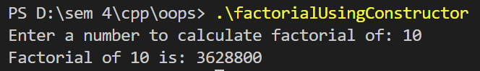

# **Viva Questions**

#### Q1) When are copy constructors called in C++?

There are some possible situation when copy constructor called in C++,

* When an object of the class is returned by value.
* When an object of the class is passed (to a function) by value as an argument.
* When an object is constructed based on another object of the same class.
* When the compiler generates a temporary object.

#### Q2) Why copy constructor takes the parameter as a reference in C++?

A copy constructor is called when an object is passed by value. The copy constructor itself is a function. So if we pass an argument by value in a copy constructor, a call to copy constructor would be made to call copy constructor which becomes a non-terminating chain of calls. Therefore compiler doesn’t allow parameters to be passed by value.

#### Q3) Why copy constructor argument should be const in C++?

There are some important reasons to use const in the copy constructor.

* const keyword avoids accidental changes.
* You would like to be able to create a copy of the const objects. But if you’re not passing your argument with a const qualifier, then you can’t create copies of const objects.
* You couldn’t create copies from temporary reference, because temporary objects are rvalue, and can’t be bound to reference to non-const.